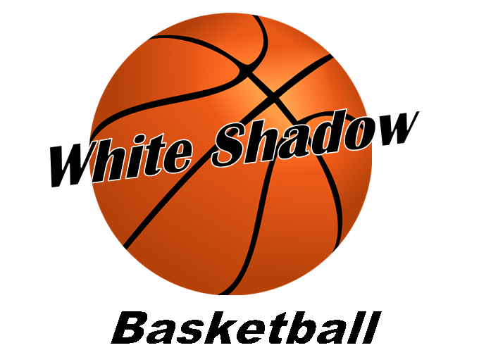
2023 Summer Basketball Tournaments (Tentative)
Date Tourn. Place
April 1-2nd Magic Tournament RR Sports Center April 15-16th Rise Up United We Stand RR Sports Center
April 29-30th Spurs Austin Classic OR Ball’ne Austin/RR Sports
Center
May 6-7th Magic Tournament-Not RR Sports Center
On Mother’s Day
May 20-21st Capital City Reg.-Primetime RR Sports Center June 3-4th Summer Games Ring Champ. Austin/RR Sports
Center
June 17-18th Ball’ne OR Gametime RR Sports Center
June 24-25th Magic 5 Star BB RR Sports Center
Fri./Sat./Sun.-7/7- Skyhook Inter. Tourn. RR Sports Center
7/9 Round Rock, Tx.

8 or 9 Tournaments
Practice Days: Mondays, Tuesdays, Thursdays, and/or Fridays
Times-TBD

Location:Round Rock Sports Center, Northeast Metro Park and/or
Crestview Baptist-Georgetown, Texas

